FLOODS NEAR RIVERS

**The most common sources of flooding are rivers and creeks. A flood occurs when a river or a stream overflows its banks caused by rainfall and excess water released by dams or reservoirs. Therefore, it is important to monitor water level in surrounding areas but manual monitoring is fraught with risk, errors and delay. With a flood monitoring system using technology, the water level can be monitored remotely.  
A non-contact water level sensor is suitable in this application with accuracy. The non-contact sensor can monitor the water level without the need to do extensive maintenance.**

[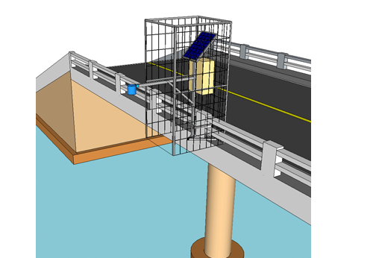](https://linkwisetech.com/wp-content/uploads/2020/03/near-river.png)

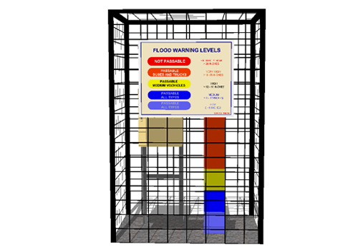

FLOODED ROADS

**During heavy rainfall, drainage and canal systems are overwhelmed by the onrushing water. And most of the time in urban areas such as Metro Manila, clog drainage system aggravates it. The excess water is left overflowing in roads and highways causing gridlocks and flooding.  
Flooding can occur with little warning but can also worsen when the rain subsides in low-lying areas serving as a catch basin. People can be caught unaware of the incoming danger of flash flooding with huge losses to properties and sometimes loss of life. A reliable flood monitoring system can minimize the losses and actions can be taken to prevent the taking of life.  
Linkwise Technology provides a flood monitoring system with contact sensor which detects and monitors water levels in roads. The remote station also provides a visual warning for motorists and pedestrians aside from sending the water level warning to the central server**.

**Since we are now currently present in an era of Computing Technology, it is essential for everyone and everything to be connected to the internet. IOT is a technology that brings us more and more close to this goal. Our project comprises of smart water monitoring system which is a small prototype for flood detection and avoidance system. This paper explains the working and the workflow of all the components present inside our project. The sensors sense the environment and sends real-time data to the cloud (firebase cloud) and users can view and access this data via their mobile platform. The model gives a warning after the water level rises to a particular height. Since it is a small scaled prototype for flood detection and avoidance system, the working of this model is good. The data are uploaded and changed in the cloud in precision to the sensor and real-time changes in the mobile application is achieved. This model can be used to greatly reduce the casualties in a devastating event of flood. Introduction: We are witnessing various drastic advancements in the fields of science and technology over the past few decades. The current industrial age has revolutionized our lives and provides us with plenty of comforts and conveniences. However, this industrial progress has come at a hefty cost of global warming and other environmental disasters such as flood, earthquake, etc. Furthermore, the loss caused by such disasters to life and property is immense. The increasing carbon footprints and greenhouse gases have severely led to an imbalance and disturbances in the natural cycle of rains and floods. Hence, we are facing the dangers of unwarned and inevitable floods more than ever before. In order to detect and avoid floods in a timely manner, technology plays a very important role. With the help of the current technology privileges, we can detect and prepare ourselves for an upcoming disaster. Studies show that such an initiative can really come in handy. In a very recent US flooding due to storms in the Midwest, loss of life and property damage were minimized due to the emergency systems available there. On the other hand, North Korea struggled to deal with the displacement of over 300,000 people, approximately 221 deaths and a cost of $6 million- most to feed the homeless survivors, and this all resulted in part from the lack of development of warning systems and information at the community level of the impending flooding. The same was seen in the floods that happened in the Indian states of Kerala and Tamil Nadu. From the above examples, we may come to the conclusion that an effective warning system is actually a serious problem to developing and underdeveloped countries. A nation like the US has a rich economy and thus, no limitations to resource usage. Warning communities of the incoming flood, therefore, is an expensive proposal given the limited resources of the countries**.

**Implementation method Figure1: The main idea in our project is to integrate two platforms android and iot in order to realize a system that is dependable of easy to access at the same time. We use Arduino and different sensors in order to collect and upload the data to a real time database and android to use this data for monitoring purpose. Hardware implementation Different hardware used in our projects are: i) Arduino Wemos D1 R1. ii) Ultrasonic sensor. iii) Flow sensor. iv) Dht11(Temperature and humidity sensor)**